Assignment VI - Web Tables
NAME: DEPURU BHARGAVA VENKATA SAI GANESH
REG NO: 212223240025

from selenium import webdriver
from selenium.webdriver.common.by import By
from selenium.webdriver.chrome.options import Options
from selenium.webdriver.support.ui import WebDriverWait, Select
from selenium.webdriver.support import expected_conditions as EC
import time

# Browser setup
options = Options()
options.add_argument("--start-maximized")

driver = webdriver.Chrome(options=options)
wait = WebDriverWait(driver, 15)

try:
driver.get("https://assertqa.com/practice/webtables")1

# Wait until the table is available
wait.until(
EC.presence_of_element_located(
(By.CSS_SELECTOR, "table")
)
)

print("Website opened successfully")

# Increase page size if a suitable dropdown exists
for dropdown in driver.find_elements(By.TAG_NAME, "select"):
values = []

for option in Select(dropdown).options:
try:
values.append(int(option.text.strip()))
except ValueError:
pass

if values and max(values) > 5:
Select(dropdown).select_by_visible_text(
str(max(values))
)
time.sleep(1)
break

# Get headings
headers = [
h.text.strip()
for h in driver.find_elements(
By.CSS_SELECTOR, "table thead th"
)
]

def get_rows():
data = []

for row in driver.find_elements(
By.CSS_SELECTOR, "table tbody tr"
):
cells = row.find_elements(By.TAG_NAME, "td")

if cells and len(cells) == len(headers):
data.append([
cell.text.strip() for cell in cells
])

return data

# TC01: Print all column headings
print("\nTC01: ALL COLUMN HEADINGS")
for heading in headers:
print(heading)

rows = get_rows()

# TC02: Print first data row
print("\nTC02: FIRST DATA ROW")
if rows:
print(rows[0])
else:
print("No employee records found")

# TC03: Print last data row
print("\nTC03: LAST DATA ROW")
if rows:
print(rows[-1])
else:
print("No employee records found")

# TC04: Search by last name
print("\nTC04: SEARCH BY LAST NAME")
search_name = "Smith"

search_boxes = driver.find_elements(
By.CSS_SELECTOR, "input[placeholder*='Search']"
)

if search_boxes:
search_box = search_boxes[0]
search_box.clear()
search_box.send_keys(search_name)
time.sleep(1)

matching_rows = get_rows()
last_name_index = next(
(i for i, h in enumerate(headers)
if h.lower() == "last name"),
None
)

found = False

for row in matching_rows:
if (last_name_index is not None
and row[last_name_index].lower()
== search_name.lower()):
print("Employee found:", row)
found = True

if not found:
print("Employee not found:", search_name)

search_box.clear()
time.sleep(1)
else:
print("Search box not found")

rows = get_rows()

# TC05: Extract all email addresses
print("\nTC05: ALL EMAIL ADDRESSES")
email_index = next(
(i for i, h in enumerate(headers)
if h.lower() == "email"),
None
)

if email_index is not None:
for row in rows:
print(row[email_index])
else:
print("Email column not found")

# TC06: Find employee with highest Salary
# Change Salary to Due if your table has a Due column.
print("\nTC06: EMPLOYEE WITH HIGHEST SALARY")

amount_index = next(
(i for i, h in enumerate(headers)
if h.lower() == "salary"),
None
)

if amount_index is not None and rows:

def get_amount(row):
return float(
row[amount_index]
.replace("$", "")
.replace(",", "")
)

highest = max(rows, key=get_amount)
print("Employee:", highest)
print("Highest Salary:", highest[amount_index])
else:
print("Salary column or employee records not found")

# TC07: Verify website link
print("\nTC07: VERIFY WEBSITE LINK")
link_text = "Home"

links = driver.find_elements(
By.XPATH,
f"//a[normalize-space(.)='{link_text}']"
)

if links:
print("PASS: Link exists")
print("Link text:", links[0].text)
print("URL:", links[0].get_attribute("href"))
else:
print("FAIL: Link not found:", link_text)

# TC08: Count data rows without header
print("\nTC08: COUNT DATA ROWS")
rows = get_rows()

print("Number of data rows:", len(rows))
print("Number of columns:", len(headers))

finally:
driver.quit()

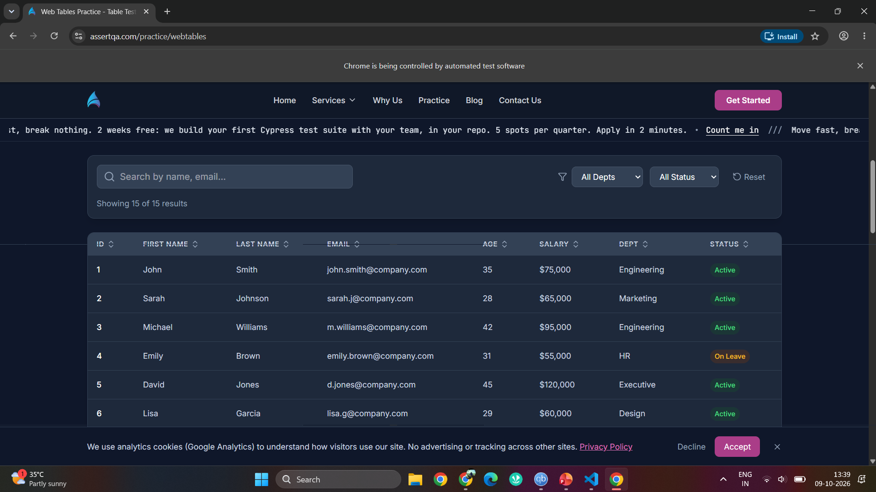
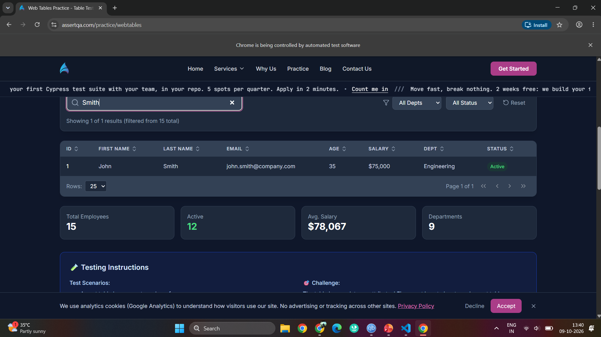
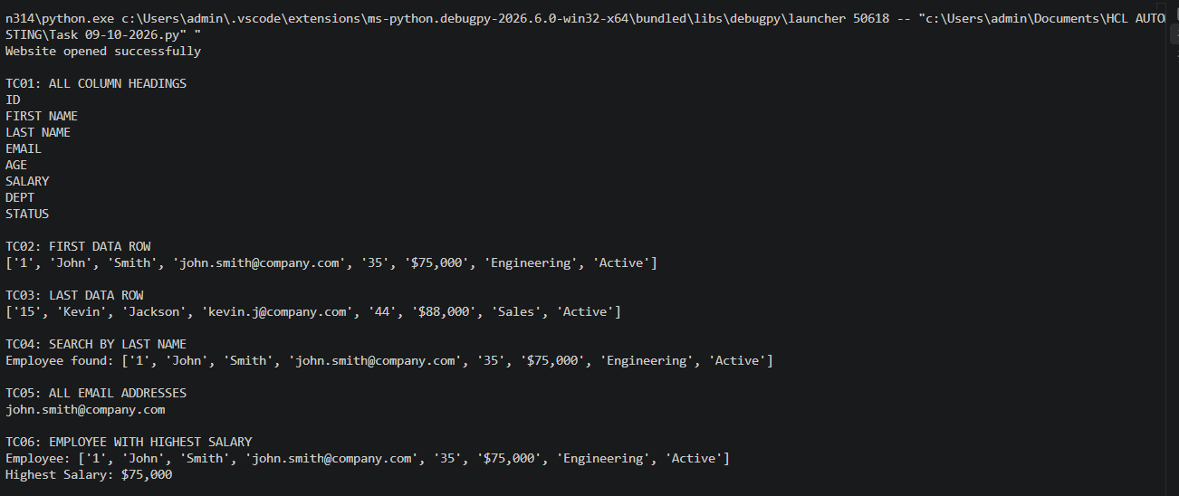
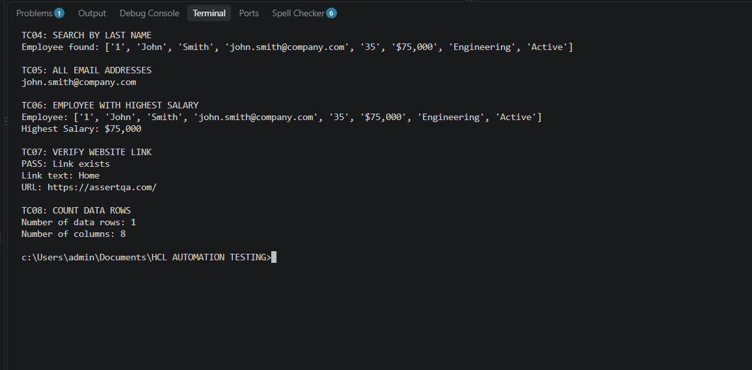

Github Link: https://github.com/saiganesh2006/MANUAL-TEST-CASES-HCL.git

